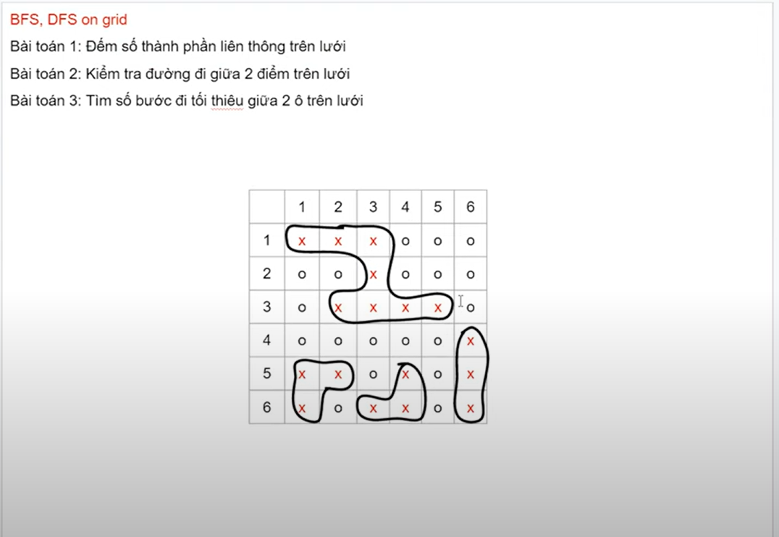

Input:

6 6

xxxooo

ooxooo

oxxxxo

ooooox

xxoxox

xoxxox

B1:



